Load Test Results

- Finding optimal batch size

Batchsize 100, flush interval 500ms, Test 1/4
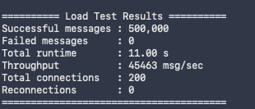

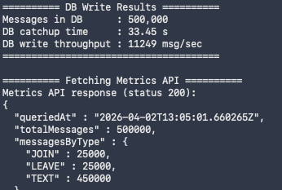
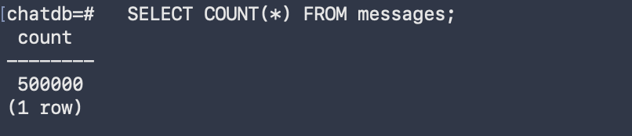

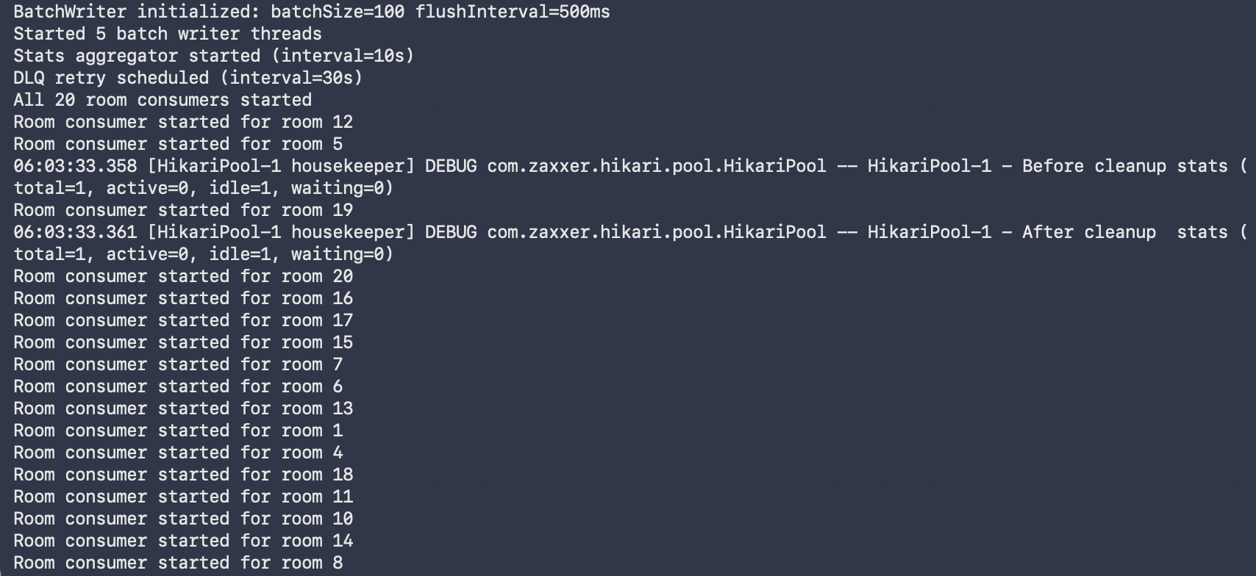
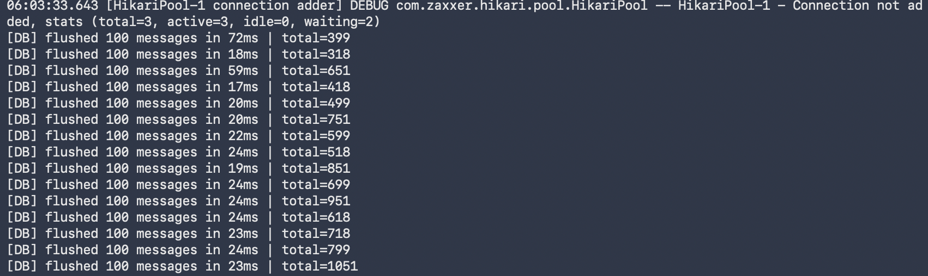

Batchsize 500, flush interval 500ms, Test 2/4
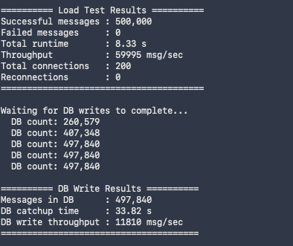
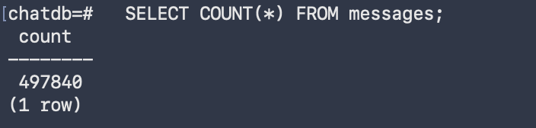
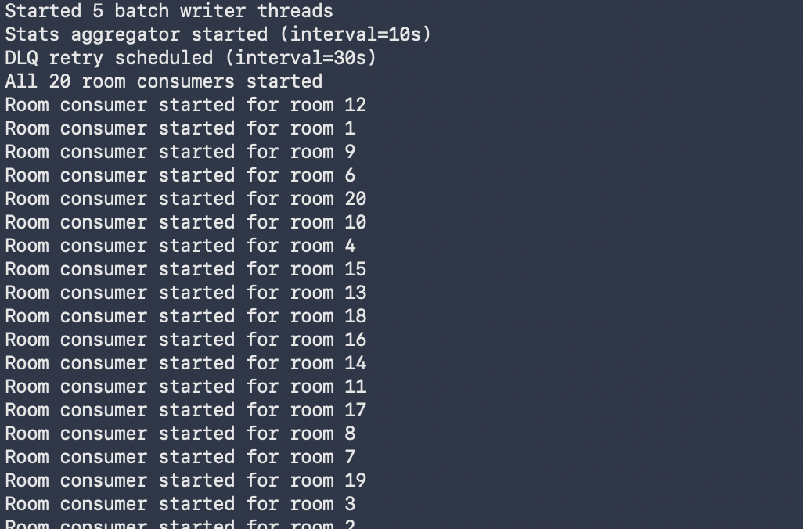

Batchsize 1000, flush interval 500ms, Test 3/4

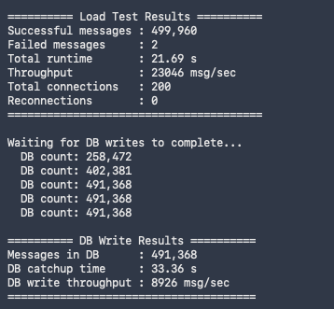
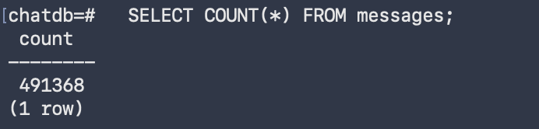
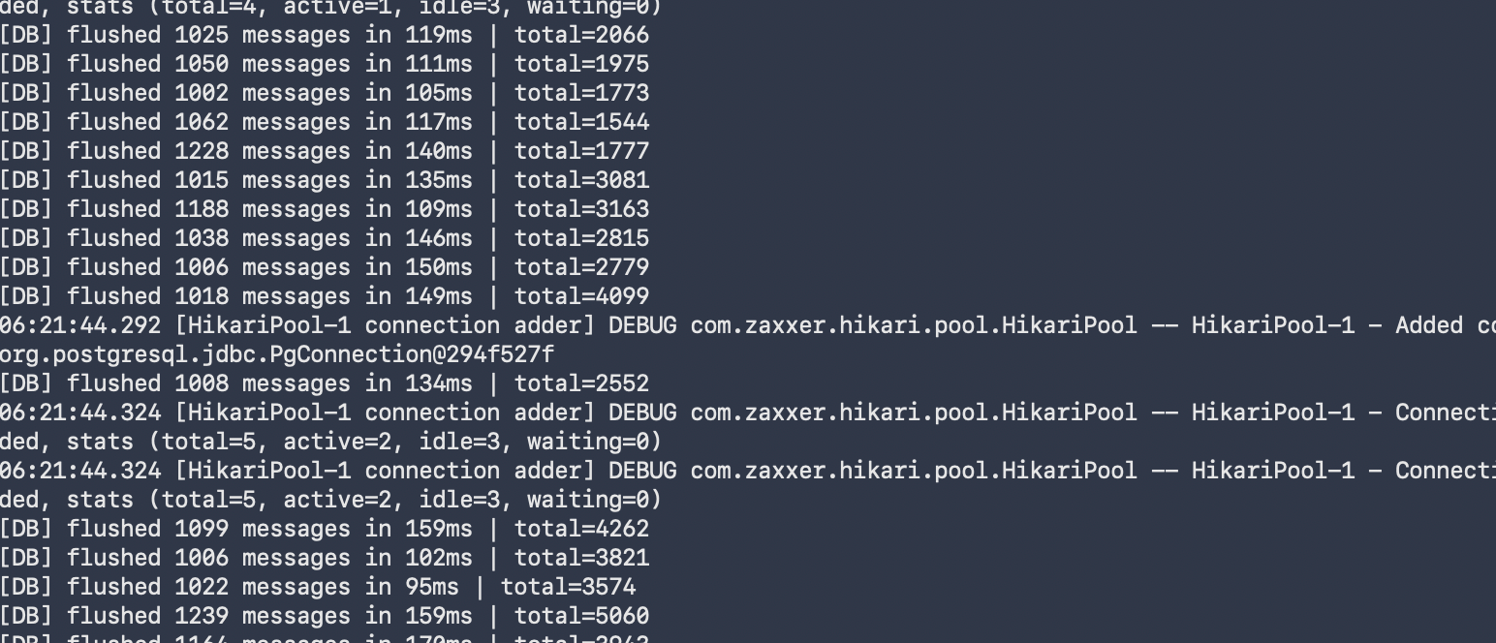

Batchsize 1000, flush interval 500ms, Test 4/4
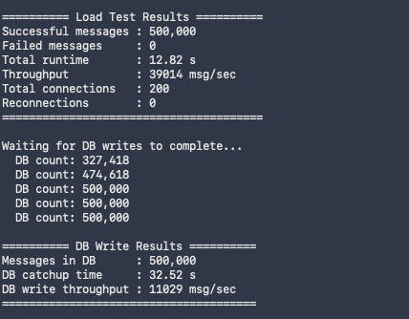
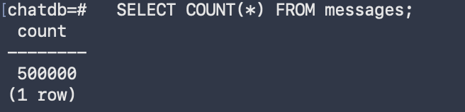
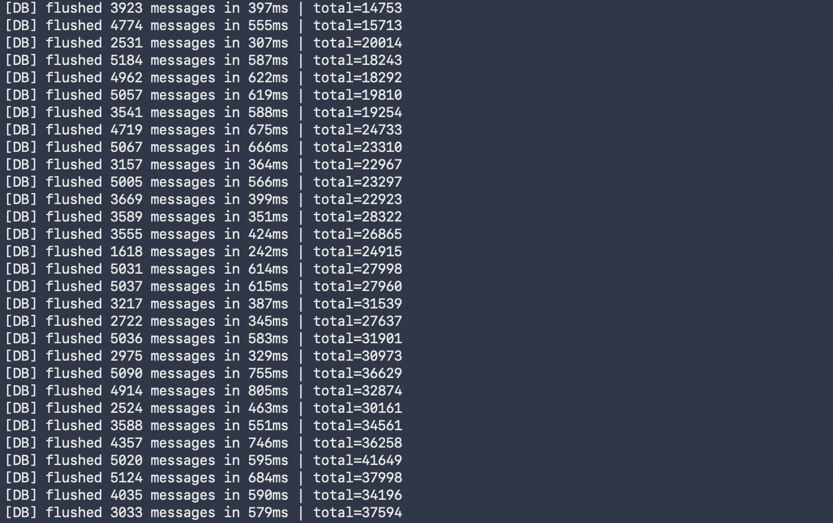

Summary:
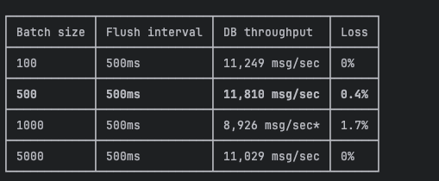
---We will go with 500 batch size for actual load testing---

- Actual Load tests with 500 batch size
-------------------------------------Test 1 Baseline-----------------------------------------
Write throughput:

Database CPU/memory:
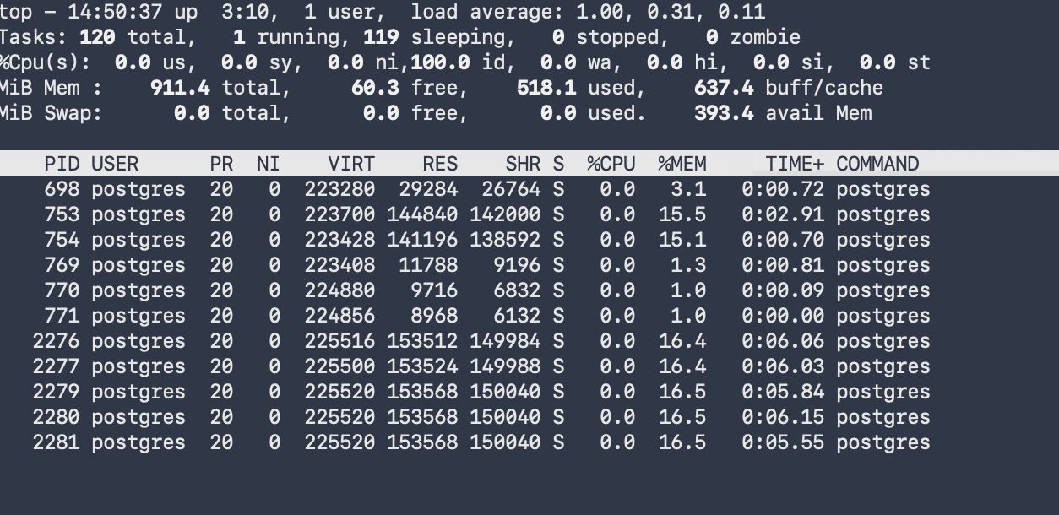
Queue depth stability:

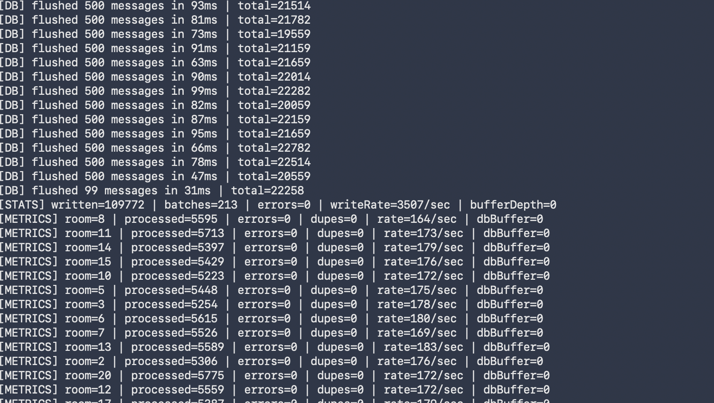
Metrics API output:
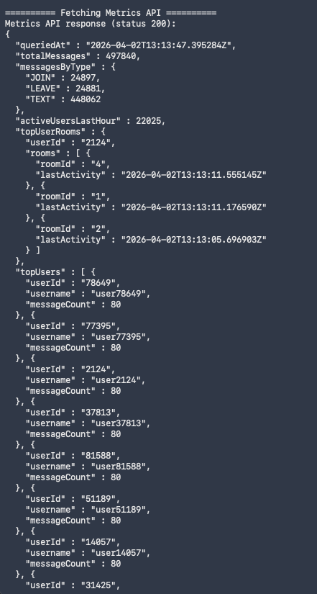
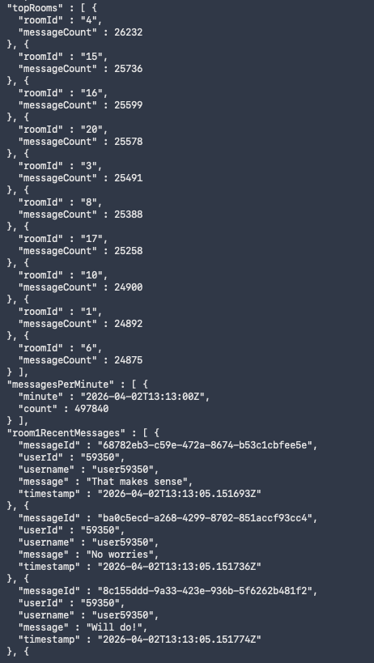
-------------------------------------Test 2 Stress Test-----------------------------------------
RabbitMQ crashed during running.
Bottleneck: RabbitMQ broker ran out of memory under sustained 1M message load on a
local machine. The broker crashed at ~200K messages queued, causing connection resets
to both the server and consumer.

Root cause: Running all components (server, consumer, RabbitMQ, client) on a single
laptop with limited RAM. In a production deployment, RabbitMQ would run on a dedicated
instance with memory limits and clustering.

-------------------------------------Test 3 Endurance Test-----------------------------------------
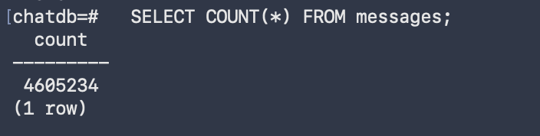
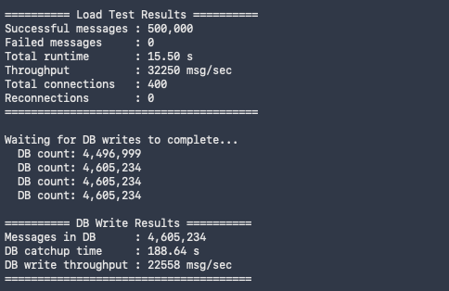
- Summary

| Metric | Value |
|--------|-------|
| Total duration | ~57 minutes |
| Total messages sent | 8,000,000 |
| Total messages in DB | 4,605,234 |
| Overall delivery rate | 57.6% |
| Sustained DB write throughput | ~20,000–23,000 msg/sec |
| Sustained WS throughput | ~24,000–34,000 msg/sec |

- Endurance Degradation Analysis

Messages reached the DB at full rate through Run 5 (~2.4M rows). Starting at Run 6, per-run DB writes dropped sharply from ~496K to ~300K and continued declining to ~170K by Run 8+.

Root cause: PostgreSQL's B-tree indexes on `room_id`, `user_id`, and `timestamp` require incremental maintenance on every batch insert. As the table grew past ~2.4M rows, page splits and index rebalancing caused batch insert time to increase significantly. The 5 writer threads fell behind the 20 consumer threads, and the shared 100K-capacity `writeBuffer` filled to capacity. Once full, `RoomConsumer.writeBuffer.offer()` returned `false` and messages were dropped (logged as `[WARN] Write buffer full`).

DB write throughput remained constant** (~22K/sec) because the writers were busy the entire time — they just couldn't keep up with the consumer arrival rate once the table grew large.

